**ETL Advanced Refresh Scenarios – Refactoring Load to SAL**

Task 01. Loading to SAL Layer Data

Users SAL_DW_CL, SAL_CL, SAL were created and granted with necessary privileges which were added in attached file init_users.sql.

***1. Loading Dimensions SCD Type 1.***

Loading dimensions SCD Type 1 (Dim_fin_sources, Dim_gen_periods, Dim_time_mm) consisted of the following steps:

* Creating views with actual data from DW Layer (by running scripts from directory \sal_dw_cl\views\);
* Creating sequences for surrogate keys generating (by running scripts from directory \sal_cl\sequences\);
* Creating tables for loading data on SAL Layer and inserting rows for not available and not defined values into them (by running scripts from directory \sal\tables\);
* Loading data in the tables from views with actual data. Packages are presented in directory \sal_cl\packages\).

Results of procedure executions for dimensions SCD Type 1 are presented below.

Dim_fin_sources:

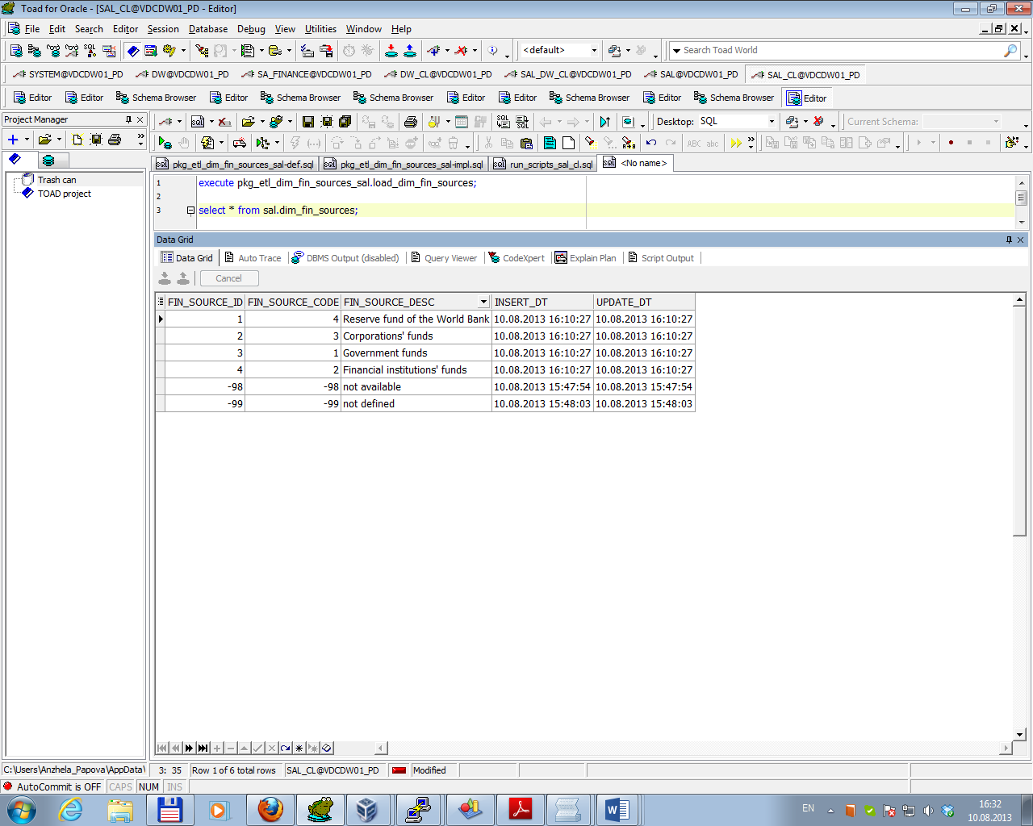

Dim_gen_periods:

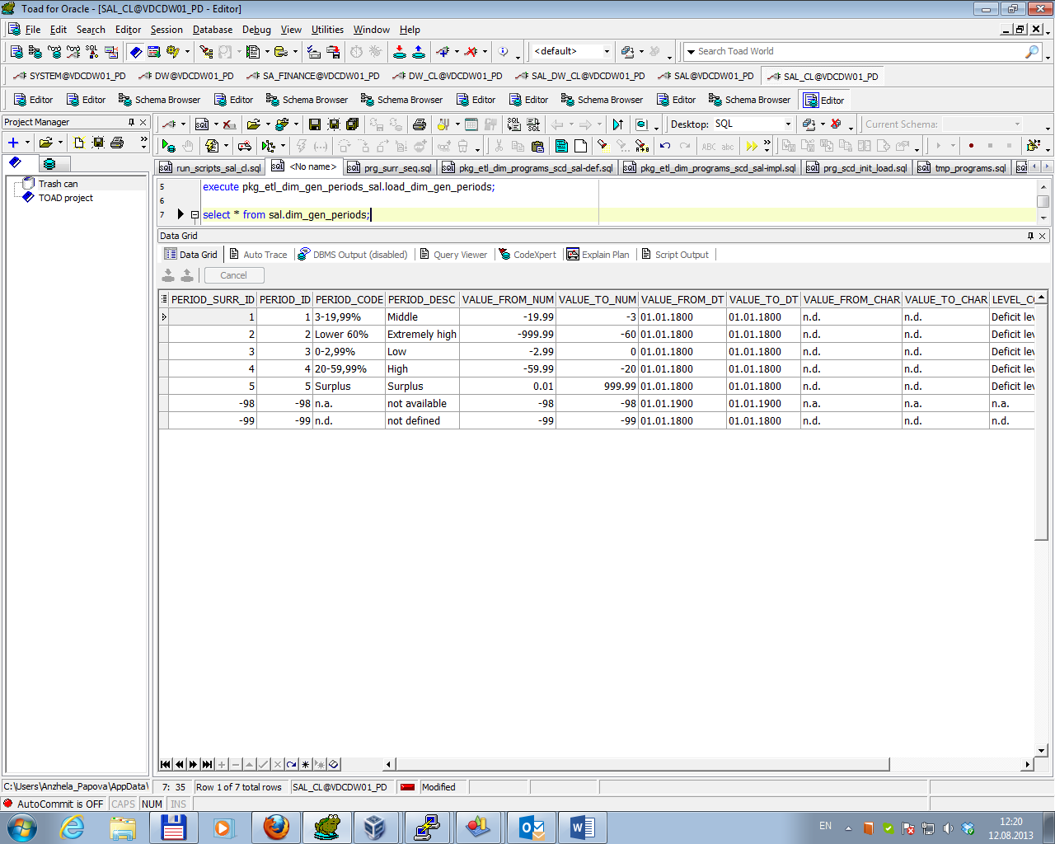

Dim_time_mm:

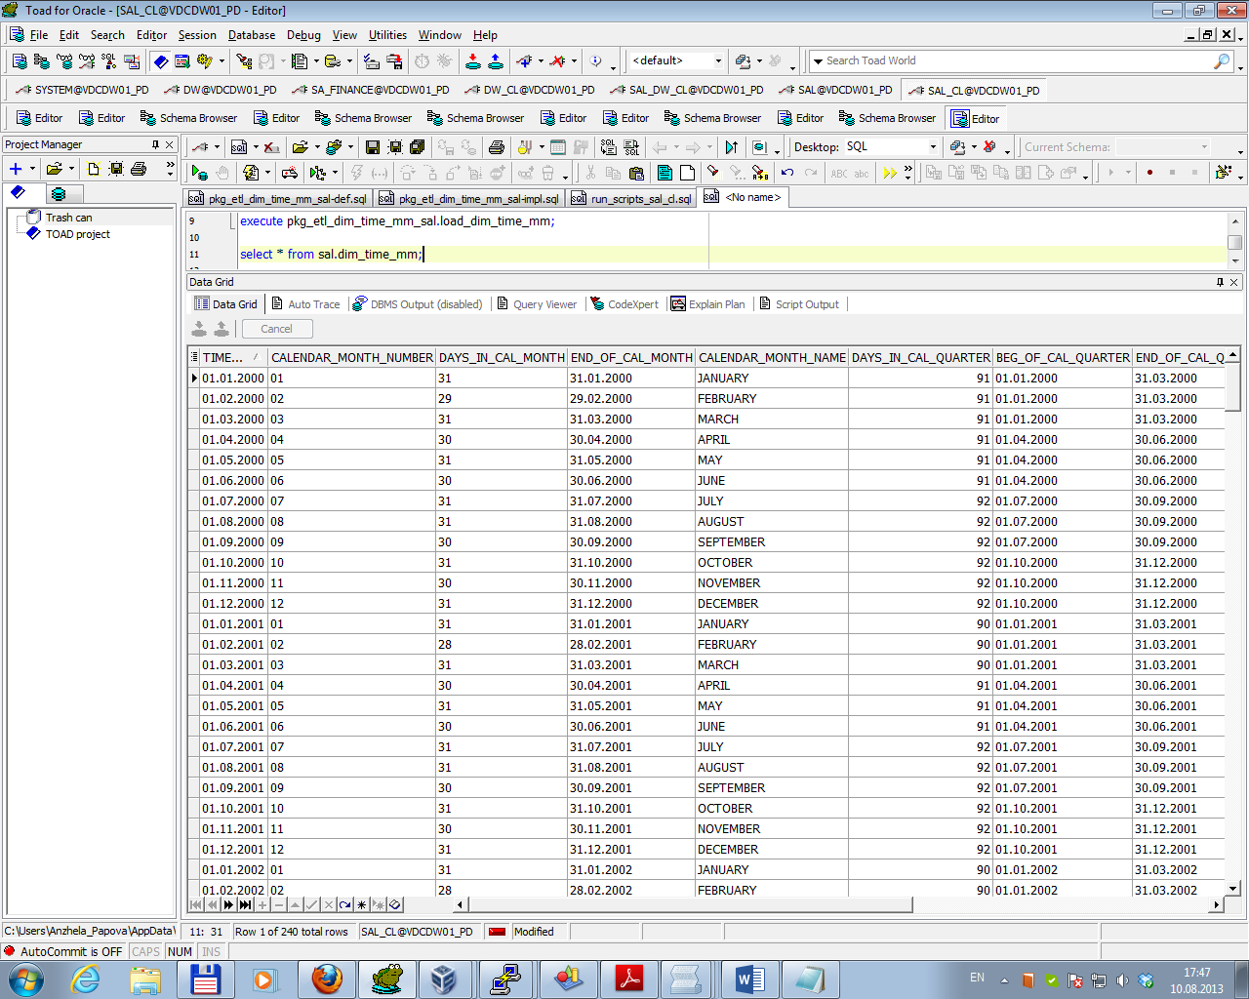

***2. Loading Dimensions SCD Type 2.***

2.1. DIM_PROGRAMS_SCD

Loading dimension Dim_programs_SCD consisted of the following steps:

* Creating sequence for surrogate key generating (by running script \sal_cl\ sequences\prg_surr_seq.sql);
* Creating table for loading data on SAL Layer and inserting rows for not available and not defined values into it (by running script \sal\tables\dim_programs_scd.sql);
* Initial data loading (as source data consists complete history programs’ managers changing) by running script \sal_cl\prg_scd_init_load.sql;

Result of initial loading is presented below.

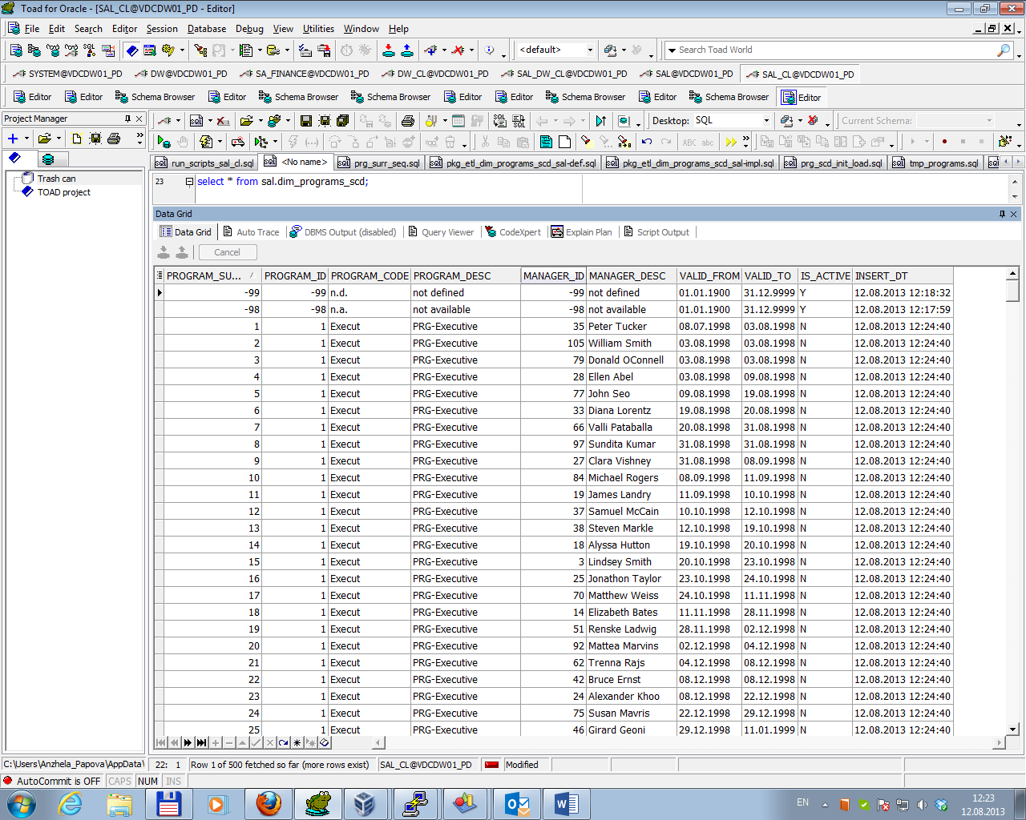

* Creating table for actual data from DW Layer (by running script \sal_dw_cl\tables\ t_act_programs.sql);
* Loading actual data in the table t_act_programs from DW Layer (by running procedure from package \sal_dw_cl\packages\pkg_etl_act_programs_dw_cl\).

Result of procedure execution is presented below.

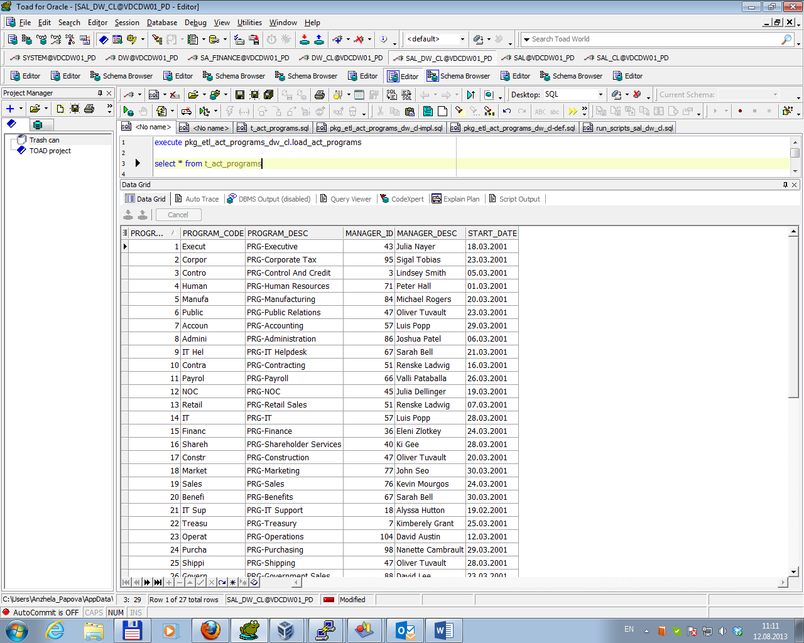

* Creating table for data to update or insert in the dimension entity dim_programs_scd (by running script \sal_cl\tables\tmp_programs.sql);
* Loading data in the table tmp_programs as difference between actual data in the table t_act_programs and data on SAL Layer from dim_programs_scd (by running procedure from package \sal_cl\packages\pkg_etl_tmp_programs_sal_cl\).

Result of procedure execution is presented below (table is empty because no data changes is gotten)

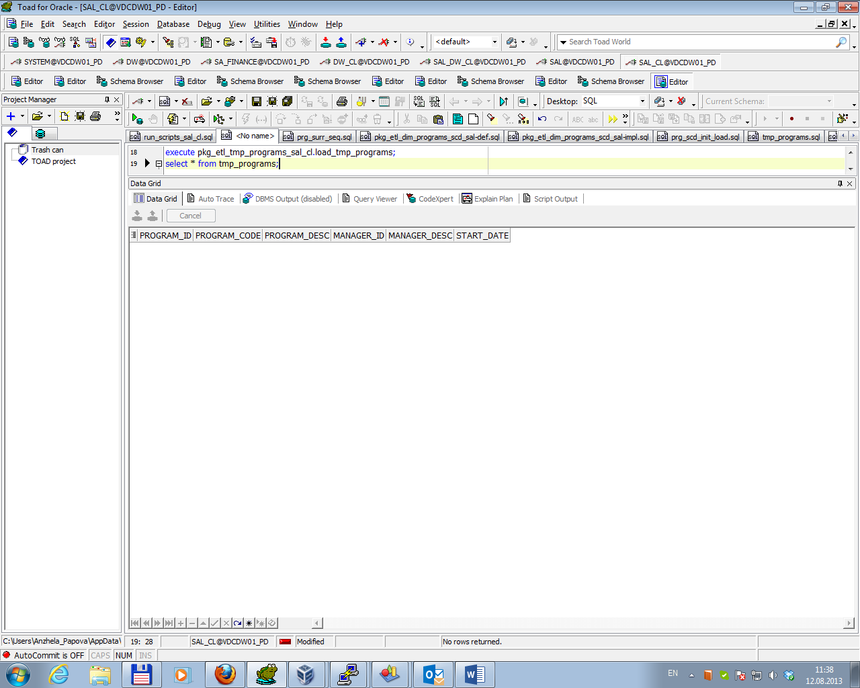

* Updating and inserting data from the table tmp_programs in the dimension entity dim_programs_scd (by running procedure from package \sal_cl\packages\ pkg_etl_dim_programs_scd_sal\).

Result of procedure execution for dimension Dim_programs_SCD is presented below.

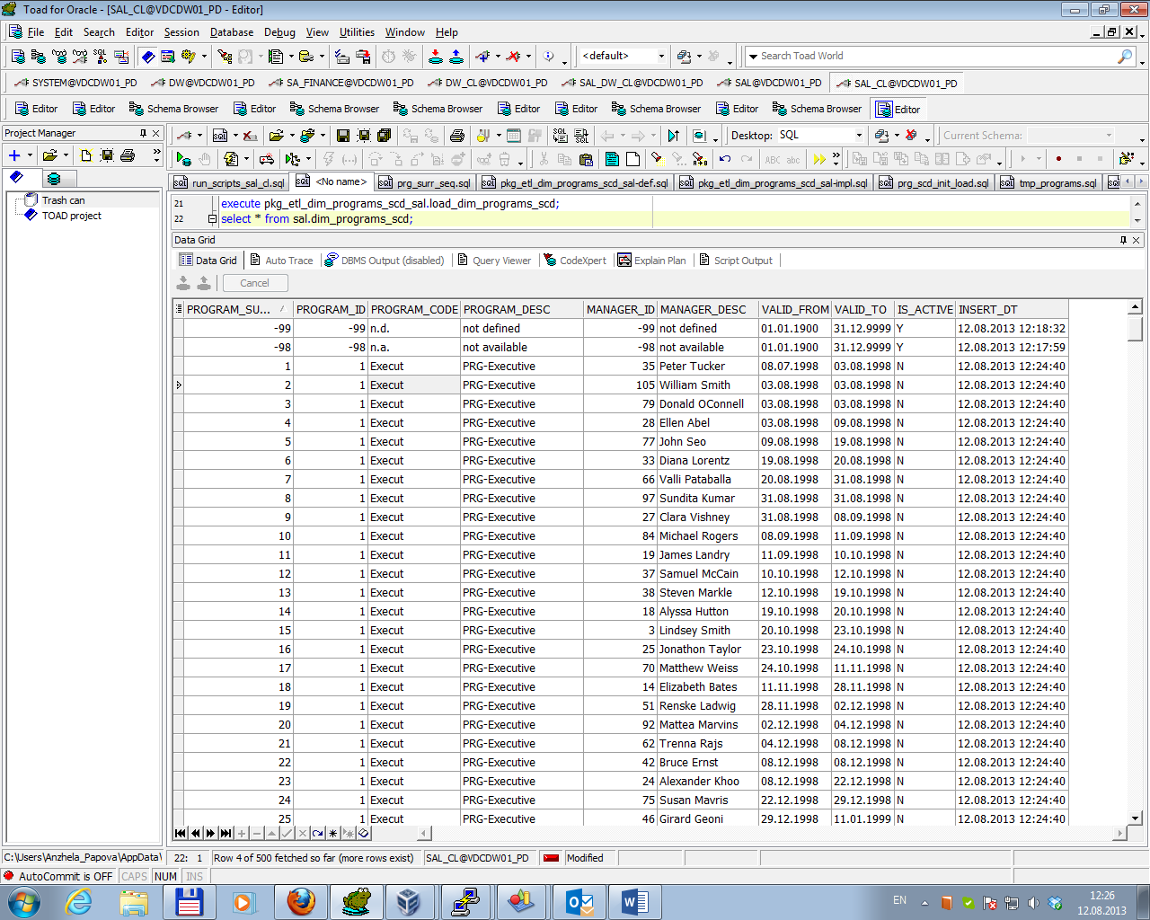

2.2. DIM_COUNTRIES_SCD

Loading dimension Dim_countries_SCD consisted of the following steps:

* Creating sequence for surrogate key generating (by running script \sal_cl\ sequences\cntr_surr_seq.sql);
* Creating table for loading data on SAL Layer and inserting rows for not available and not defined values into it (by running script \sal\tables\ dim_countries_scd.sql);
* Creating table for actual data from DW Layer (by running script \sal_dw_cl\tables\ t_act_countries.sql);
* Loading actual data in the table t_act_countries from DW Layer (by running procedure from package \sal_dw_cl\packages\ pkg_etl_act_countries_dw_cl\).

Result of procedure execution is presented below.

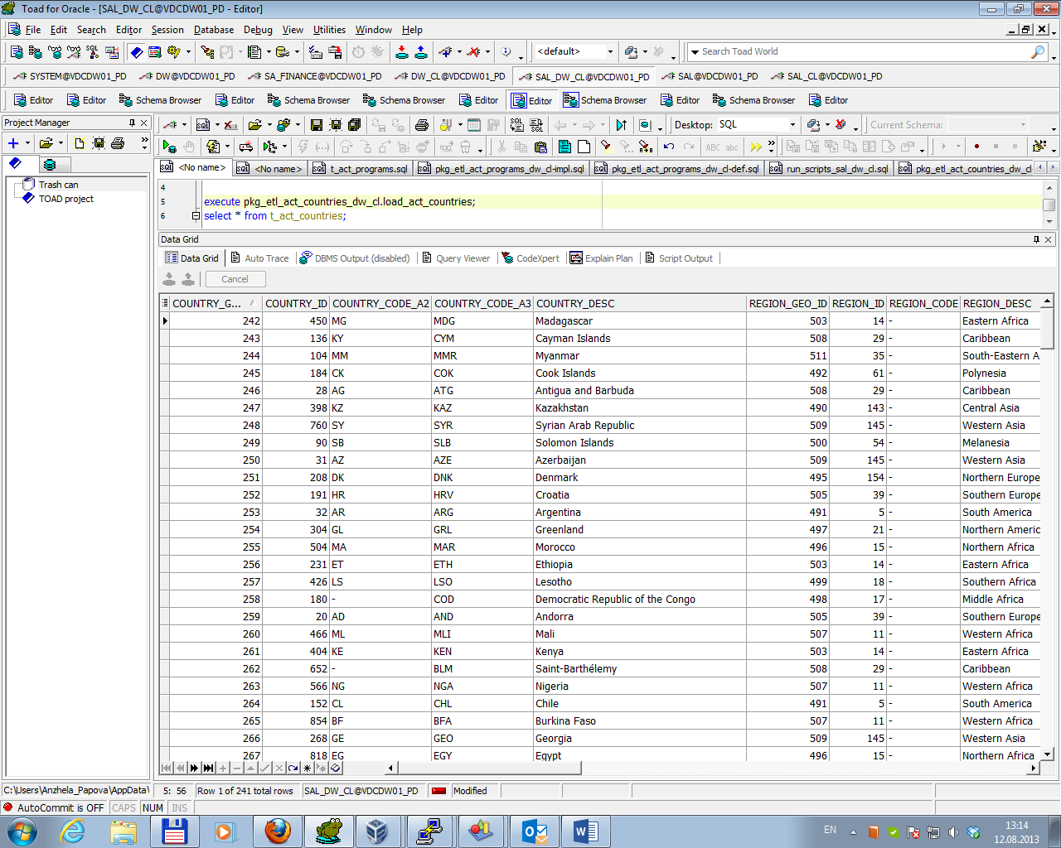

* Creating table for data to update or insert in the dimension entity dim_countries_scd (by running script \sal_cl\tables\tmp_countries.sql);
* Loading data in the table tmp_countries as difference between actual data in the table t_act_countries and data on SAL Layer from dim_countries_scd (by running procedure from package \sal_cl\packages\pkg_etl_tmp_countries_sal_cl\).

Result of procedure execution is presented below.

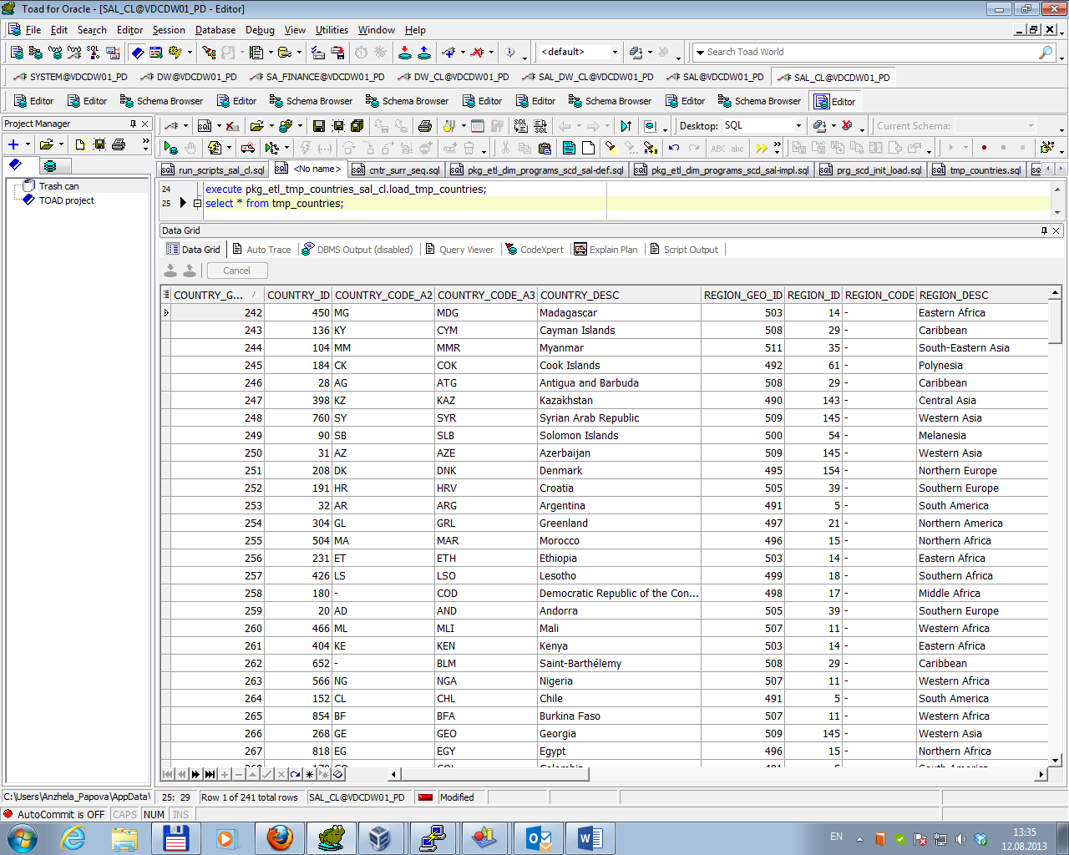

* Updating and inserting data from the table tmp_countries in the dimension entity dim_countries_scd (by running procedure from package \sal_cl\packages\ pkg_etl_dim_countries_scd_sal\).

Result of procedure execution for dimension Dim_countries_SCD is presented below.

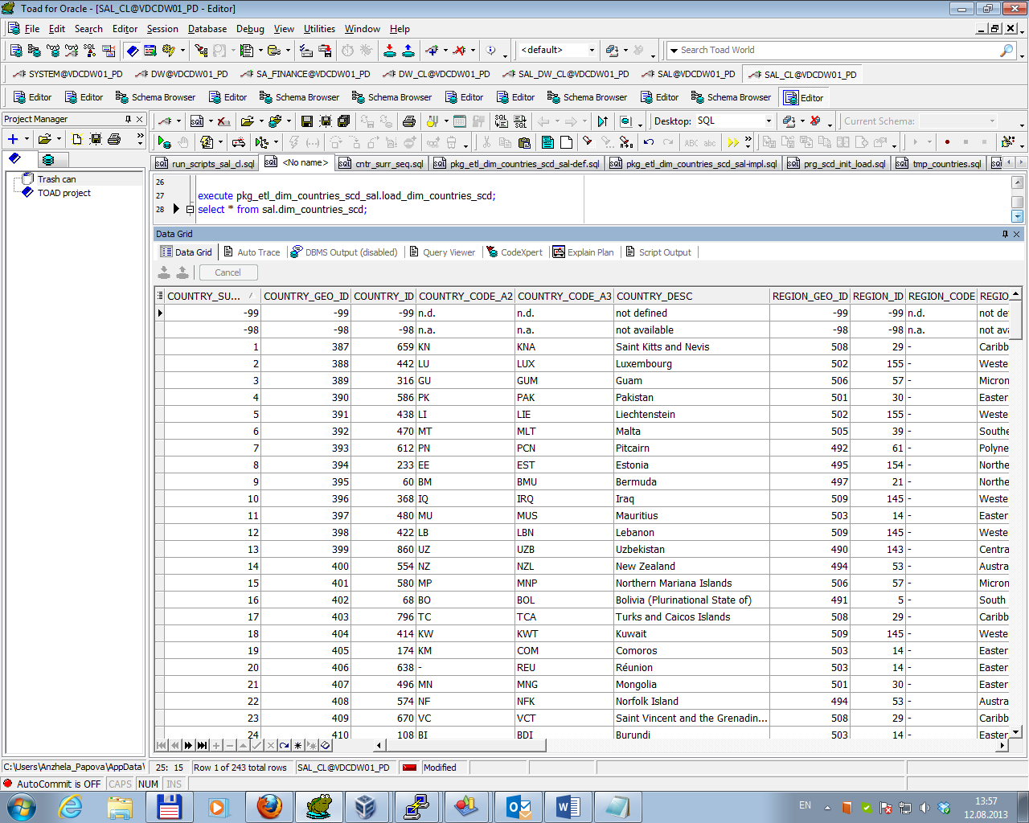

To test correctness of the scripts for country_id = 266 (country_geo_id = 380) Country_desc was changed from ‘Gabon’ to ‘Gabon – new country’. Then the actual data was loaded into table t_act_countries.

Difference between actual data in the table t_act_countries and data on SAL Layer from dim_countries_scd was gotten by running procedure from package \sal_cl\packages\pkg_etl_tmp_countries_sal_cl\. Result of procedure execution is presented below.

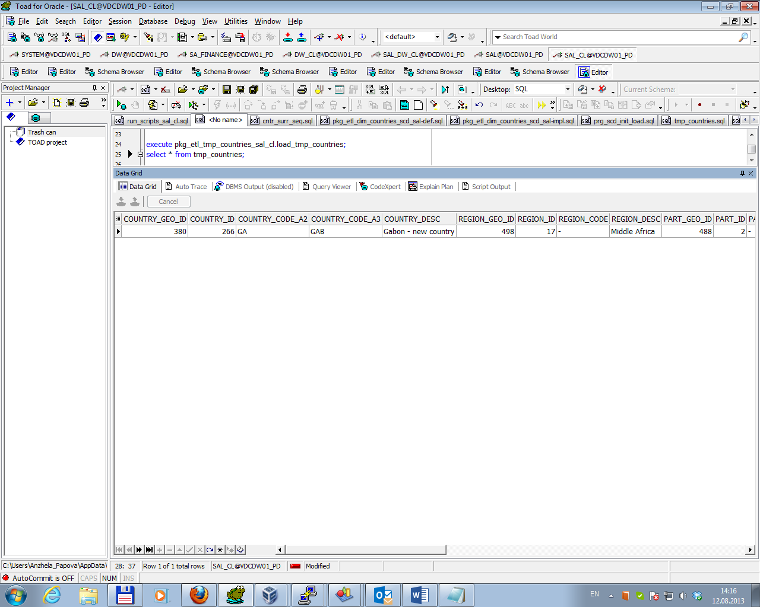

Then data was updated and inserted in the dimension entity dim_countries_scd (by running procedure from package \sal_cl\packages\ pkg_etl_dim_countries_scd_sal\). Result of procedure execution for dimension Dim_countries_SCD is presented below (two rows with country_id = 266 and country_geo_id = 380 and different values of Country_desc).

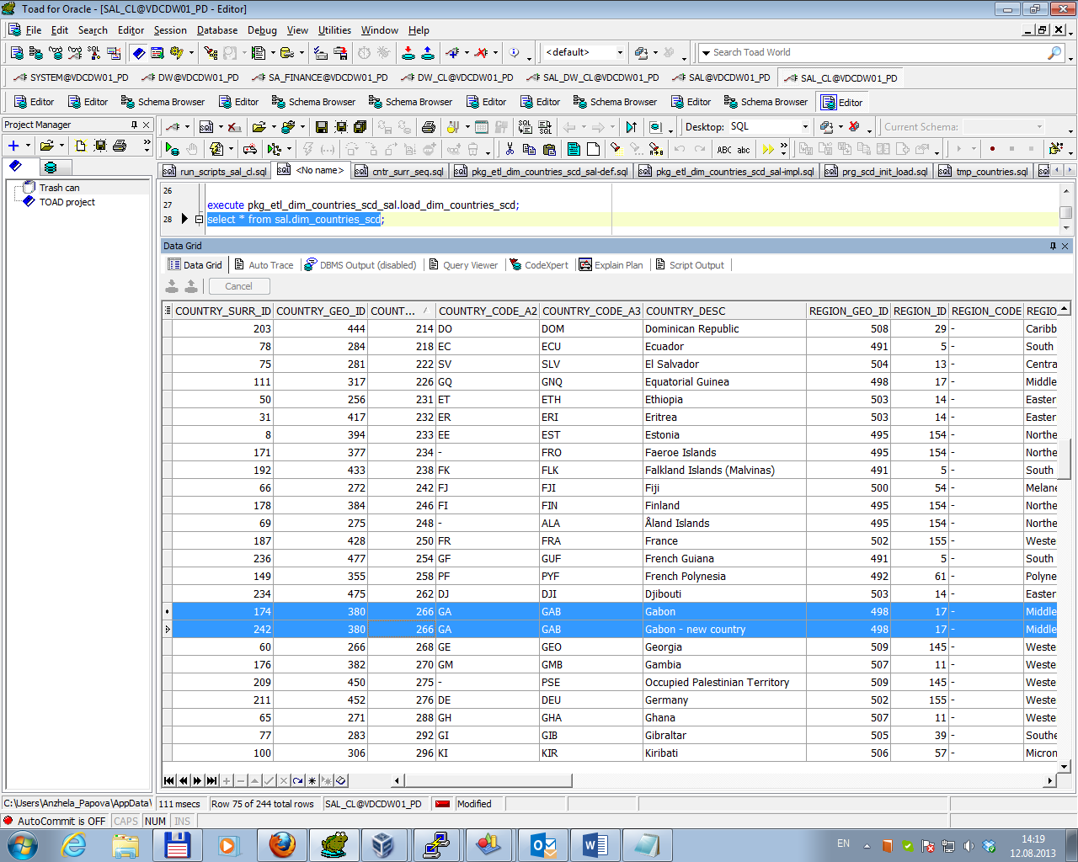

***3. Loading Fact entity.***

Loading fact table FCT_WB_Fin_countries_MM consisted of the following steps:

* Creating table for loading data on SAL Layer by running script \sal\tables\ fct_wb_fin_countries_mm.sql);
* Creating table for all data from DW Layer which should be inserted into fact table FCT_WB_Fin_countries_MM by running script \sal_dw_cl\tables\ t_act_fct_finances.sql;
* Loading data in the table t_act_fct_finances from DW Layer for current and previous years by running procedure from package \sal_dw_cl\packages\ pkg_etl_act_countries_dw_cl\ (according business requirements data should be updated by overwriting data for current and previous years);

Result of procedure execution is presented below.

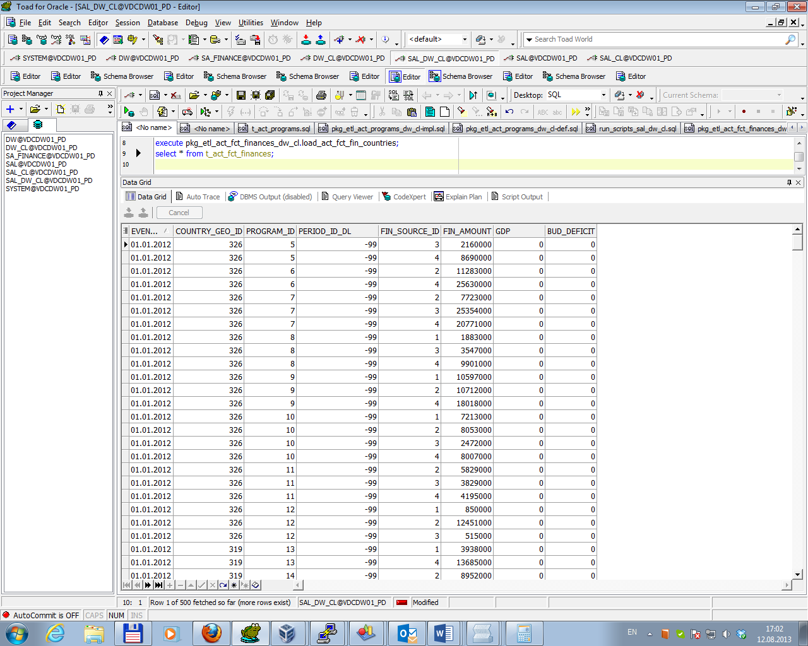

* Creating table (with the same structure as fact table) for data from DW Layer which should be inserted into fact table FCT_WB_Fin_countries_MM using the Exchange Partition operation by running script \sal_cl\tables\tmp_fct_finances.sql;
* Inserting data from the table t_act_fct_finances into table tmp_fct_finances (with dividing data according partition rules of fact table) and overwriting data in the fact table FCT_WB_Fin_countries_MM using the Exchange Partition operation by running procedure from package \sal_cl\packages\pkg_etl_fct_wb_fin_countries_ mm_sal\.

Result of procedure execution for fact table FCT_WB_Fin_countries_MM is presented below.

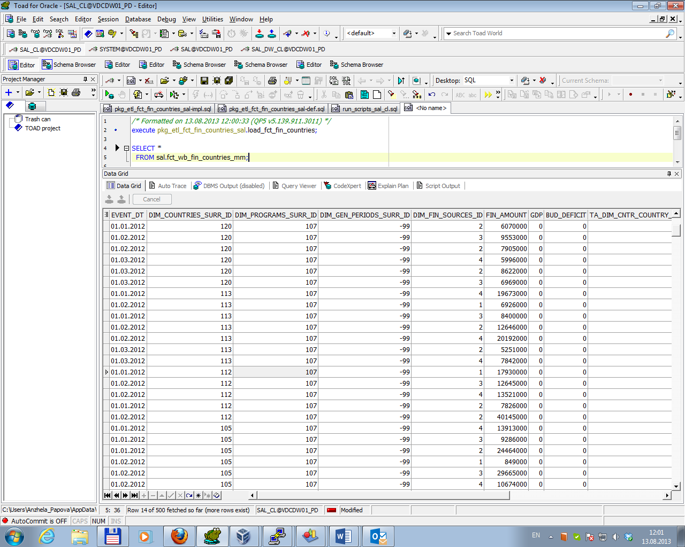

**Business Task – Performance of STAR Scheme**

Task 02. Prepare Report Layout

Ad Hoc SQL for Report Layout Quarterly that was developed on Labwork 2 using STAR schema objects for source of Data is in file WB_Funding_quarterly_SAL.sql.

Result of script running is presented below.

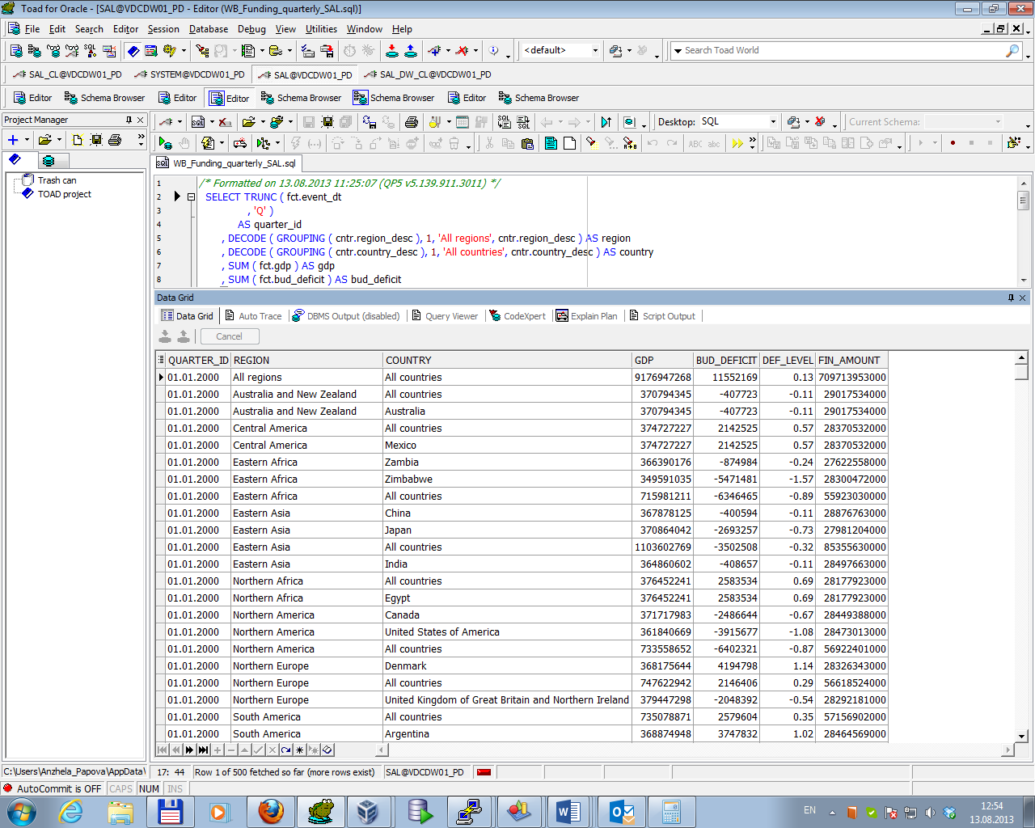

Task 03. Compare Report Layout Performance

Summarize table with comparison performance of different Report Layouts is presented below.

|  |  |  |  |  |  |
| --- | --- | --- | --- | --- | --- |
| № | Source Type | Explain Plan – Statistics (Cost) | | | Time |
| cost | bytes | cardinality |
| 1 | Advancing Grouping (Labwork 02) | 3 526 | 6 035 | 71 | 1:02 mins |
| 2 | Model Clause (Labwork 05) | 6 | 223 200 | 1 800 | 51msecs |
| 3 | Star Schema (Labwork 11) | 4 353 | 1 480 380 | 26 916 | 359msecs |